Accelerator Physics Homework #6
- Below is one FODO cell for the LHC. The total cell length is 107m and the phase advance per cell is ~90 degrees. If one quad is accidentally rotated by 1 degree, what would be the minimum tune separation in x and y caused by the resulting coupling?
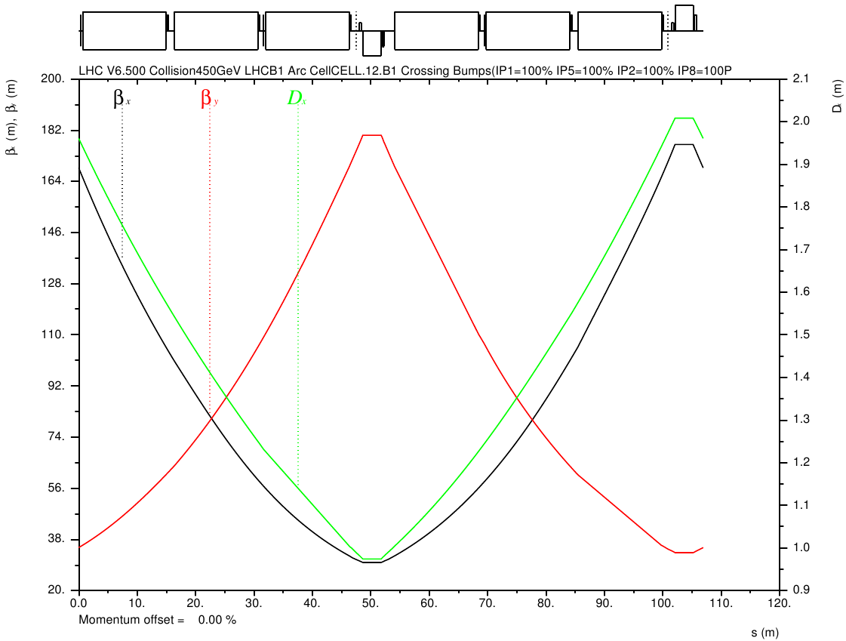
- Calculate the power lost to synchrotron radiation and the vertical synchrotron damping times for the following machines. Show the equations you use, but definitely use a spreadsheet to simplify the calculations.
Machine | Particle type | Circumference | Bend radius of magnets | Beam Current | Energy
LEP | Electrons | 27 km | 3.5 km | 5 mA | 45 GeV
 |  |  |  |  | 104 GeV
LHC | Protons | 27 km | 3 km | 600 mA | 7 TeV
HE-LHC | Protons | 27 km | 3 km | 600 mA | 16.5 TeV

- S&E 8.8 (Hint: In the lab frame, you need only to calculate the effects of the fields produced by one bunch on the particles in the other bunch and plug them into the equations).

Highest energy reached during LEP II run.
Proposed for 2030 or later.

